***Statistics Practical***

**1. Use the internal/own database and run the following operators also explain the output.**

**data(), dim(), names(), View(), str(), ls(), rm()**

#data() returns a list of currently loaded datasets or loads a dataset.

#dim() is used to get or set the dimension of the specified matrix, array or data frame.

#name() returns names of the columns

#The View() invokes a spreadsheet-style data viewer on a matrix-like R object.

#str() is used for compactly displaying the internal structure of a R object.

#ls() is used to list the names of all the objects that are present in the working directory.

#lists all objects from the memory

#rm() is used to delete objects from the memory.

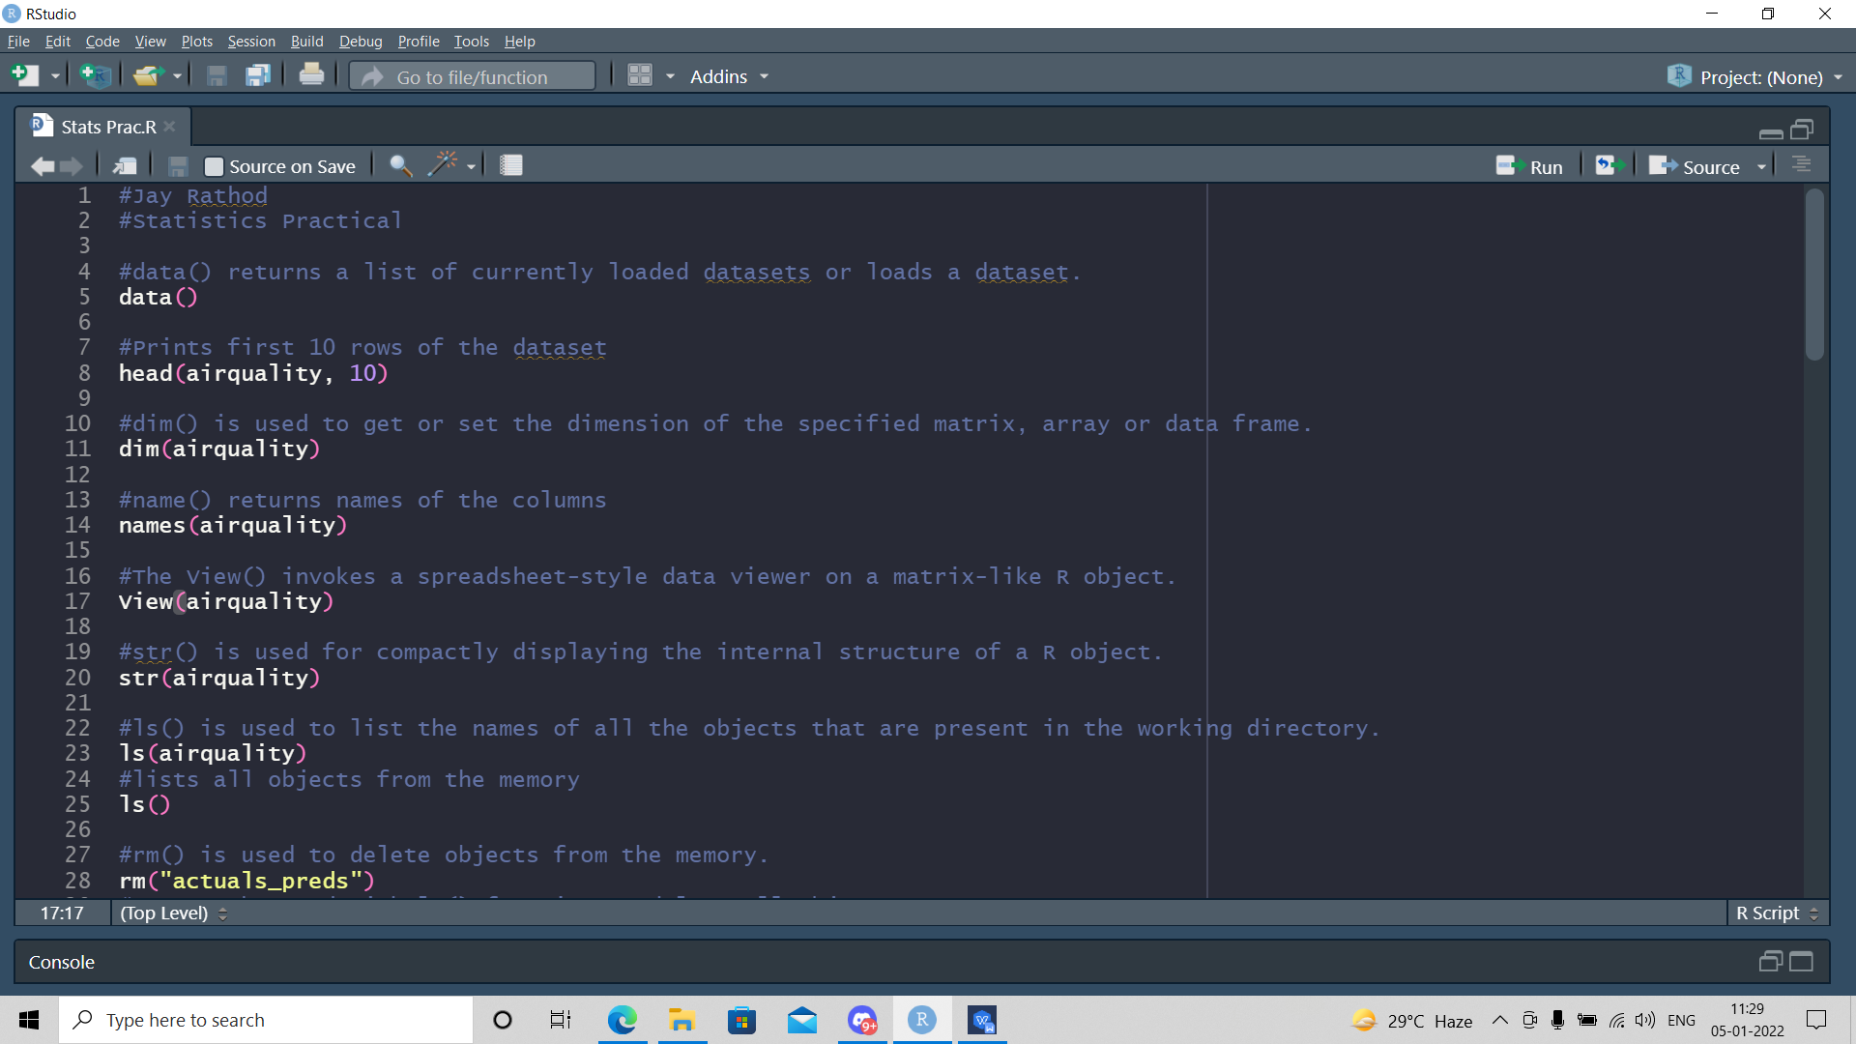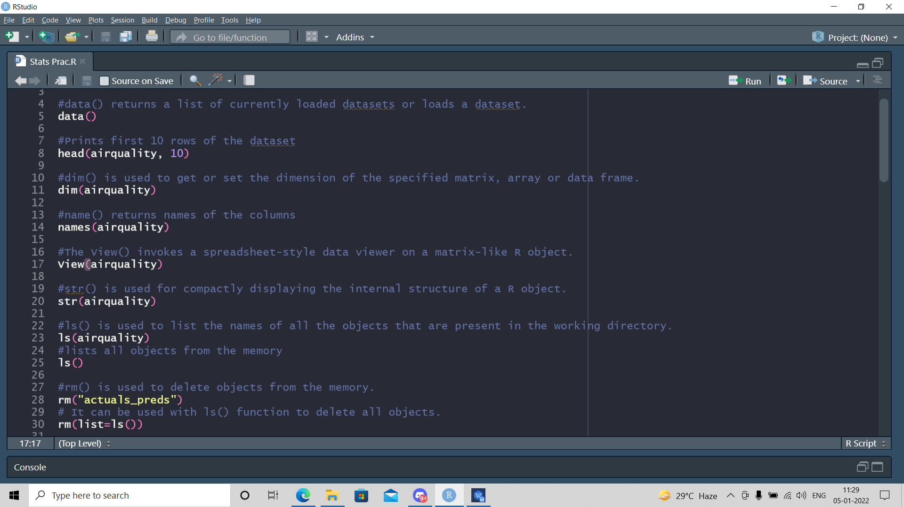

***Output:***

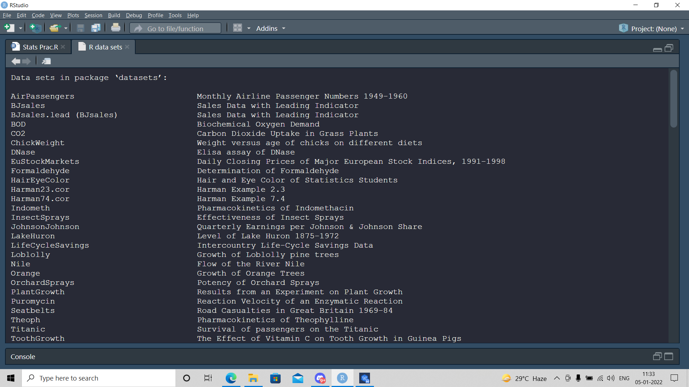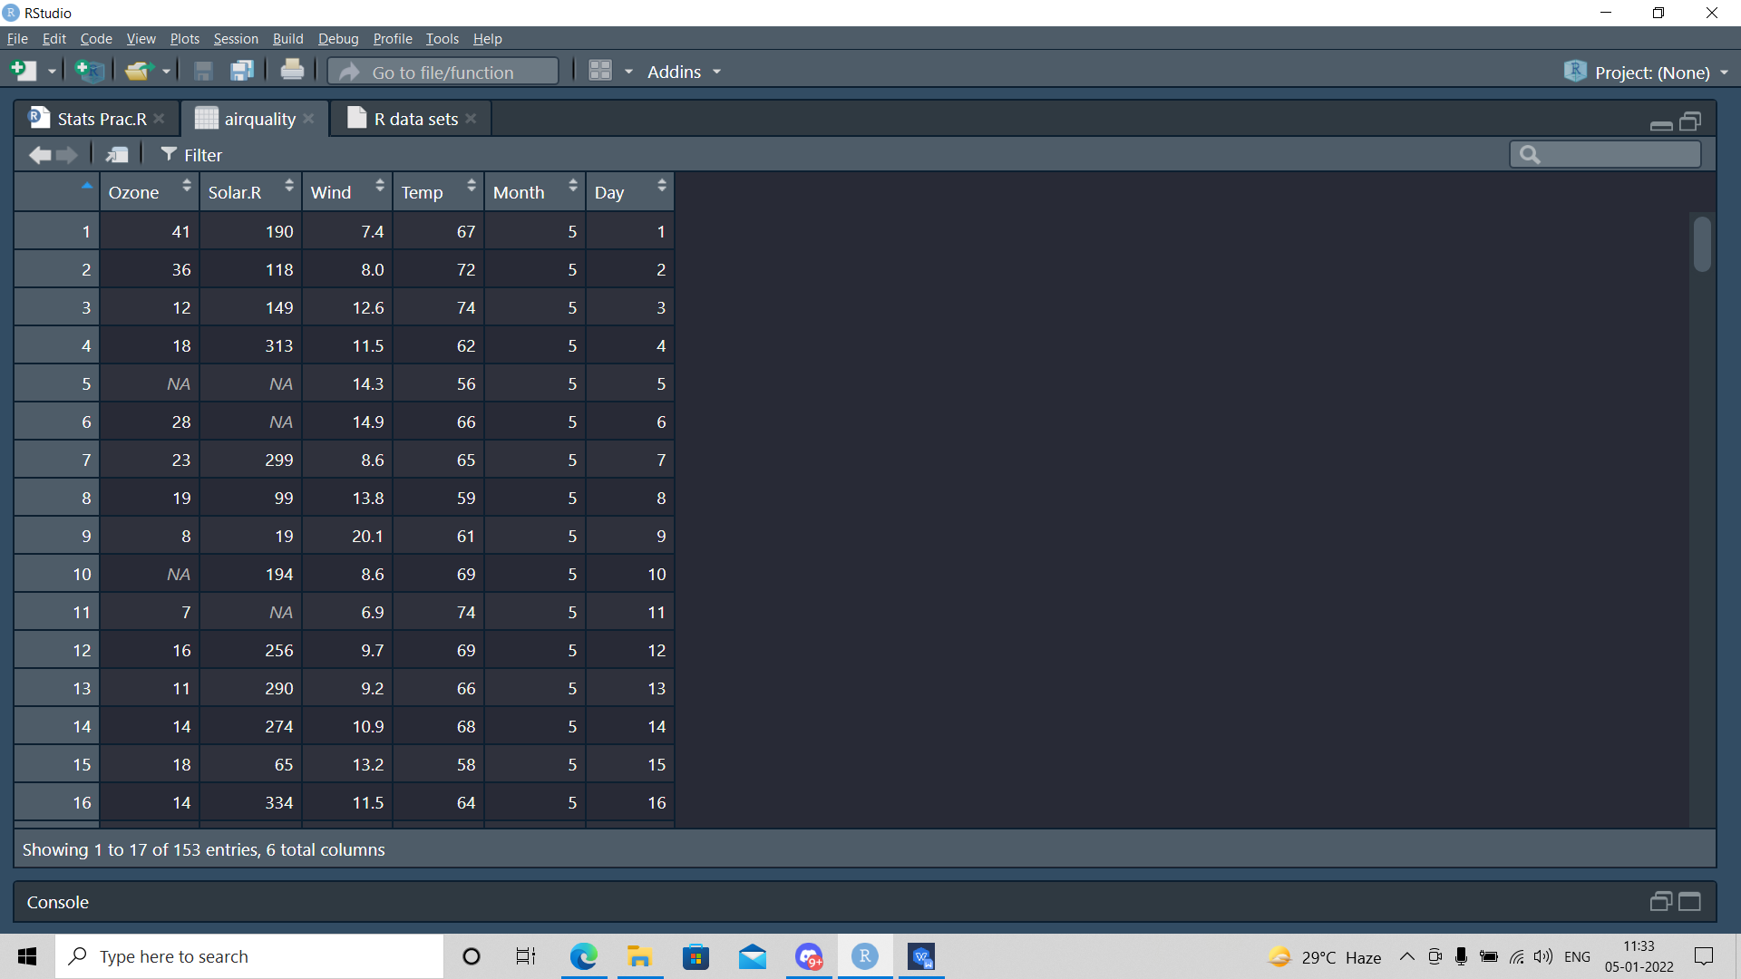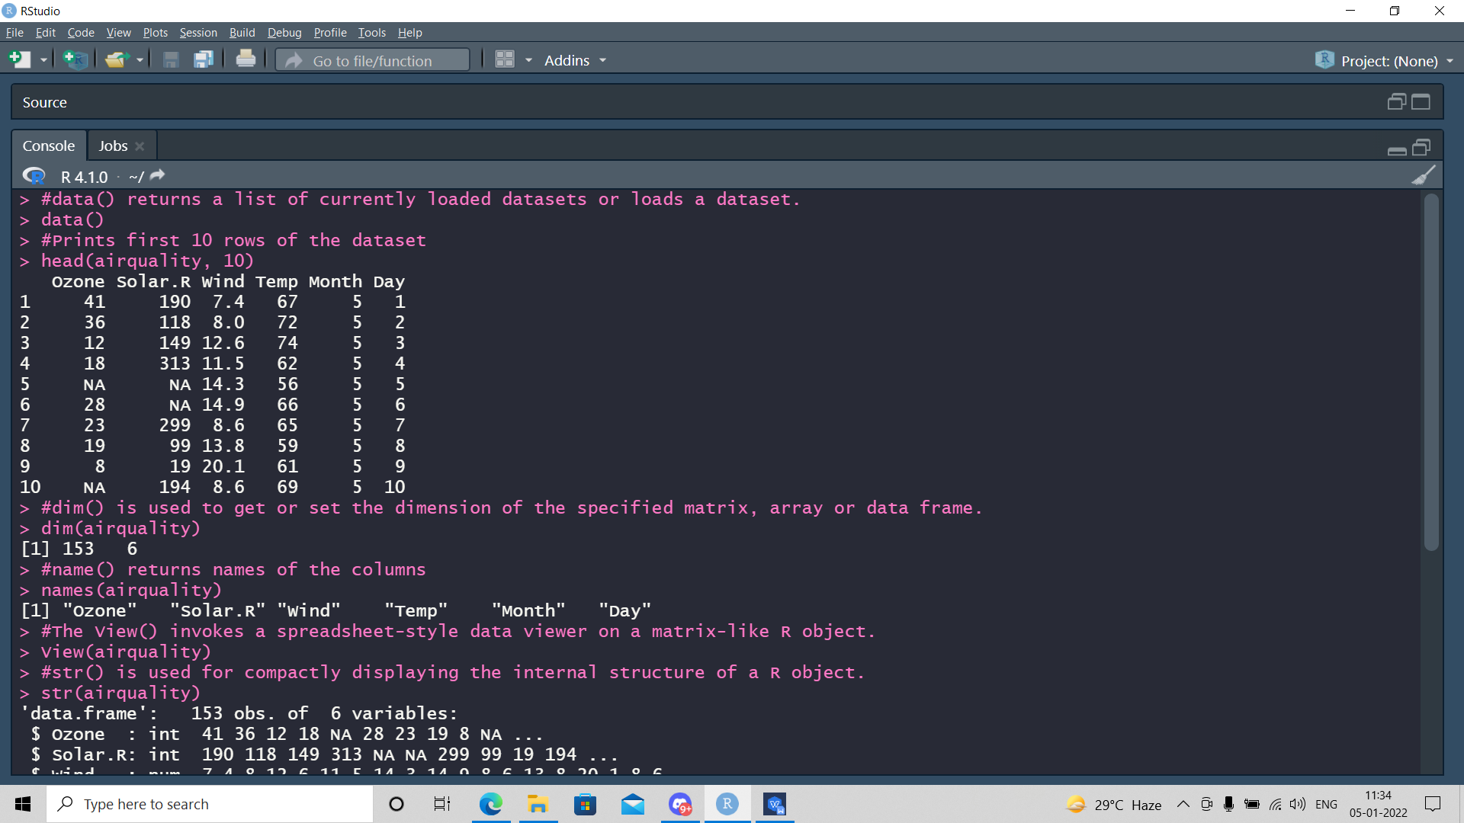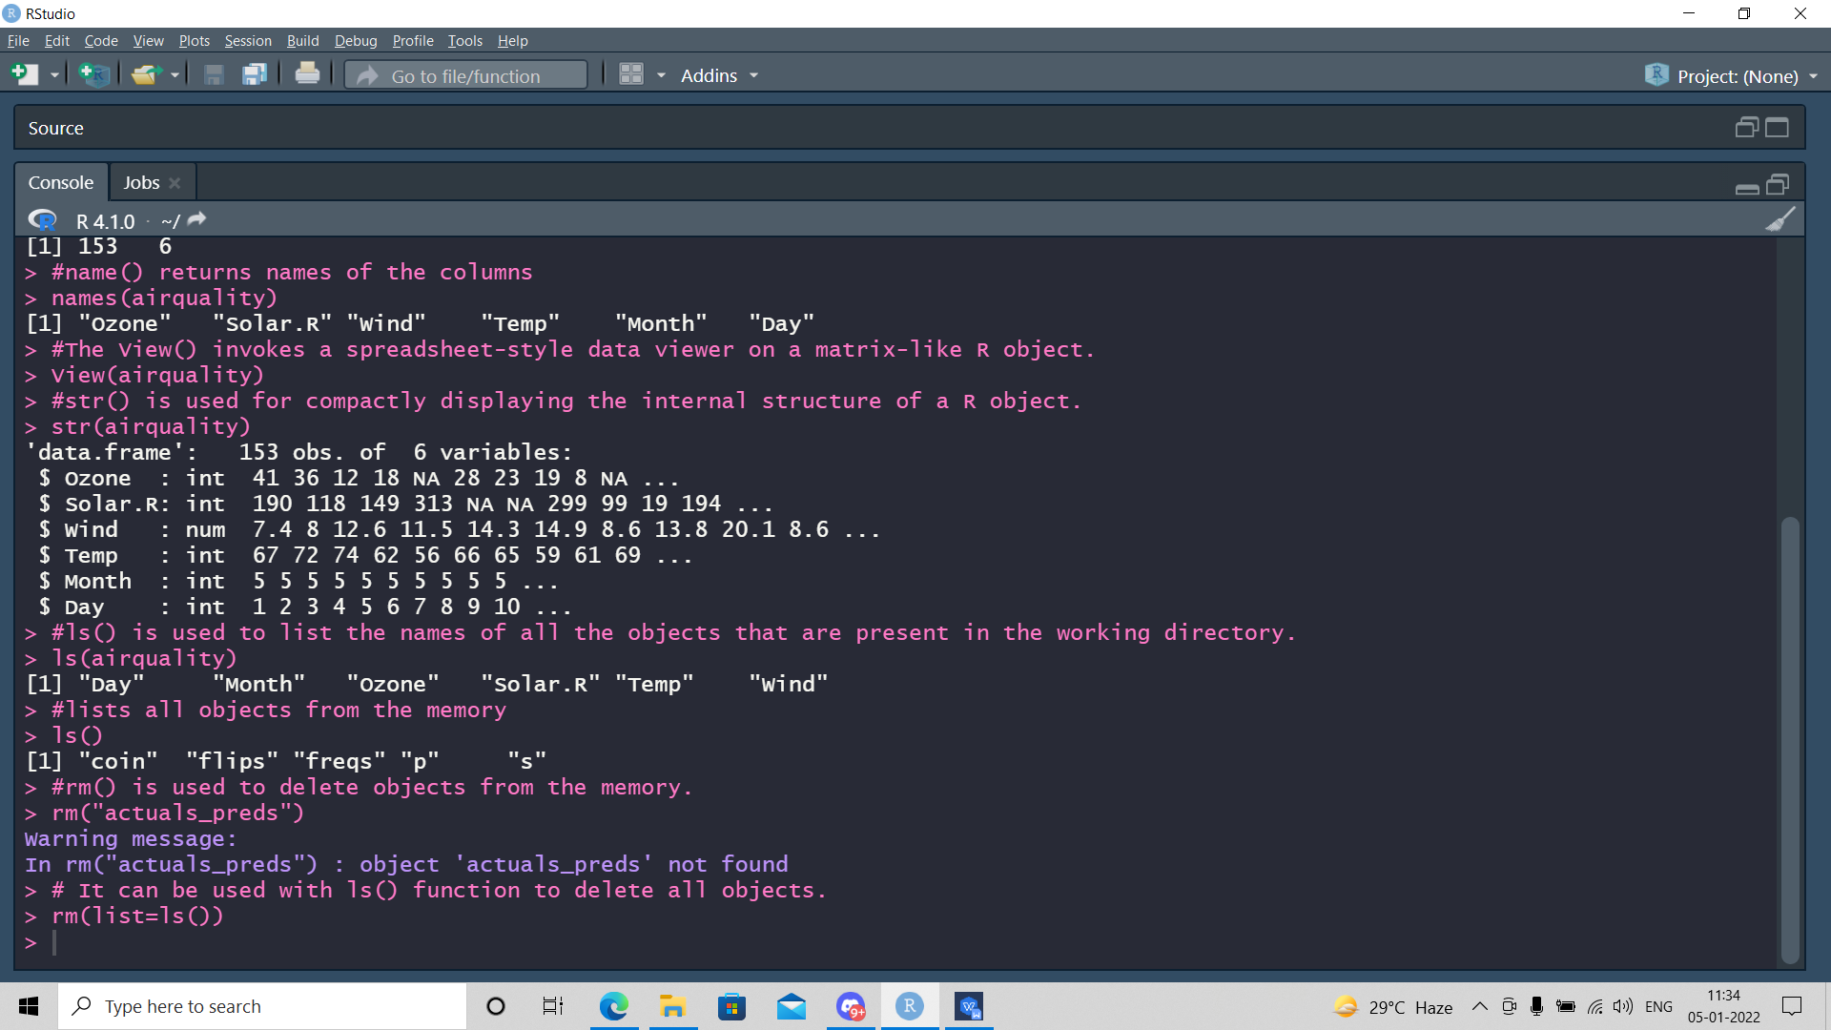

**2. Find the correlation coefficient of eruption duration and waiting time in the data set faithful.**

**Observe if there is any linear relationship between the variables.**

# eruptions waiting

# eruptions 1.0000000 0.9008112

# waiting 0.9008112 1.0000000

# Since the correlation values are greater than 0.2 there is a significant relationship between eruptions and waiting

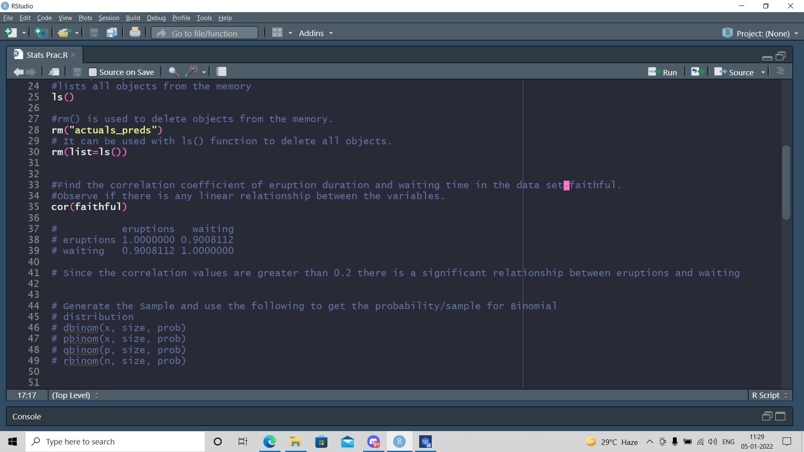

***Output:***

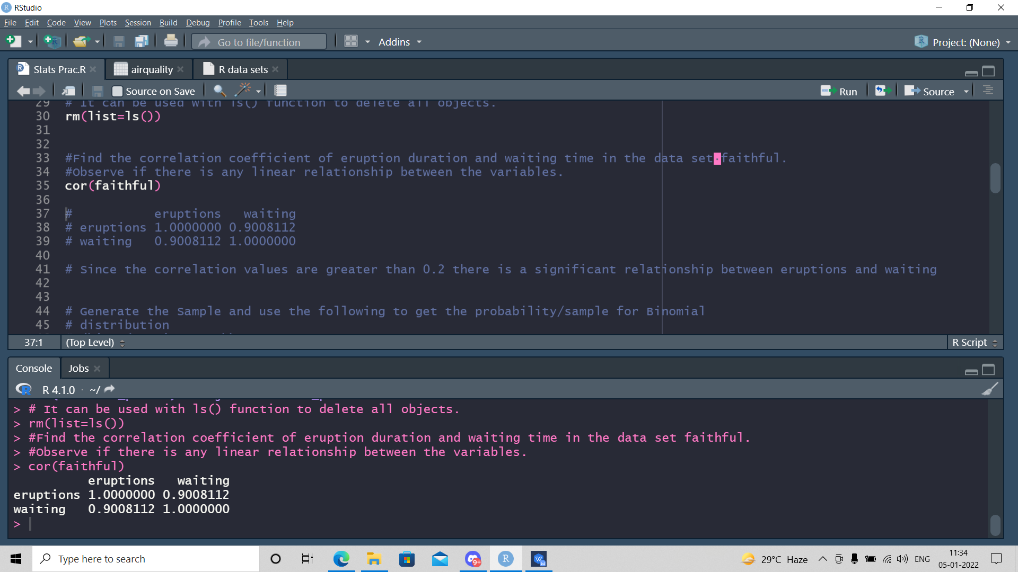

**3. Generate the Sample and use the following to get the probability/sample for Binomial**

**distribution**

**dbinom(x, size, prob)**

**pbinom(x, size, prob)**

**qbinom(p, size, prob)**

**rbinom(n, size, prob)**

#dbinom gives the probability density distribution at each point.

#pbinom gives the cumulative probability of an event.

#qbinom takes the probability value and gives a number whose cumulative value matches the probability value.

#rbimon generates required number of random values of given probability from a given sample

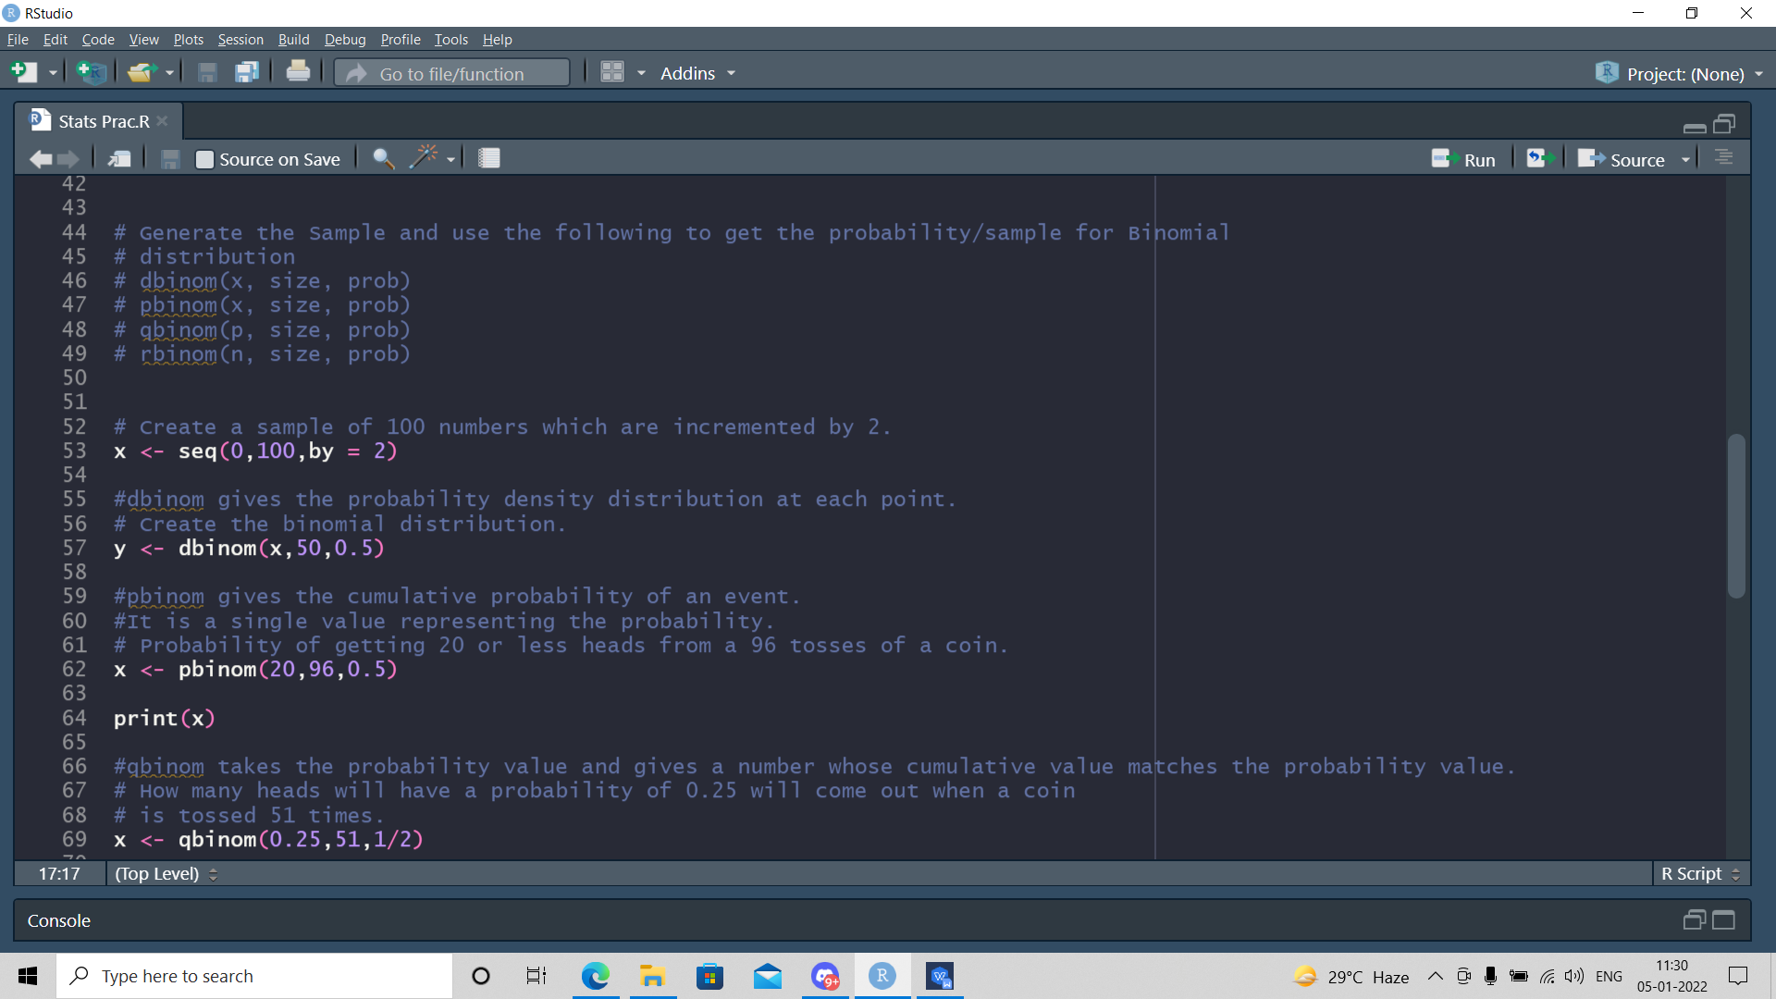

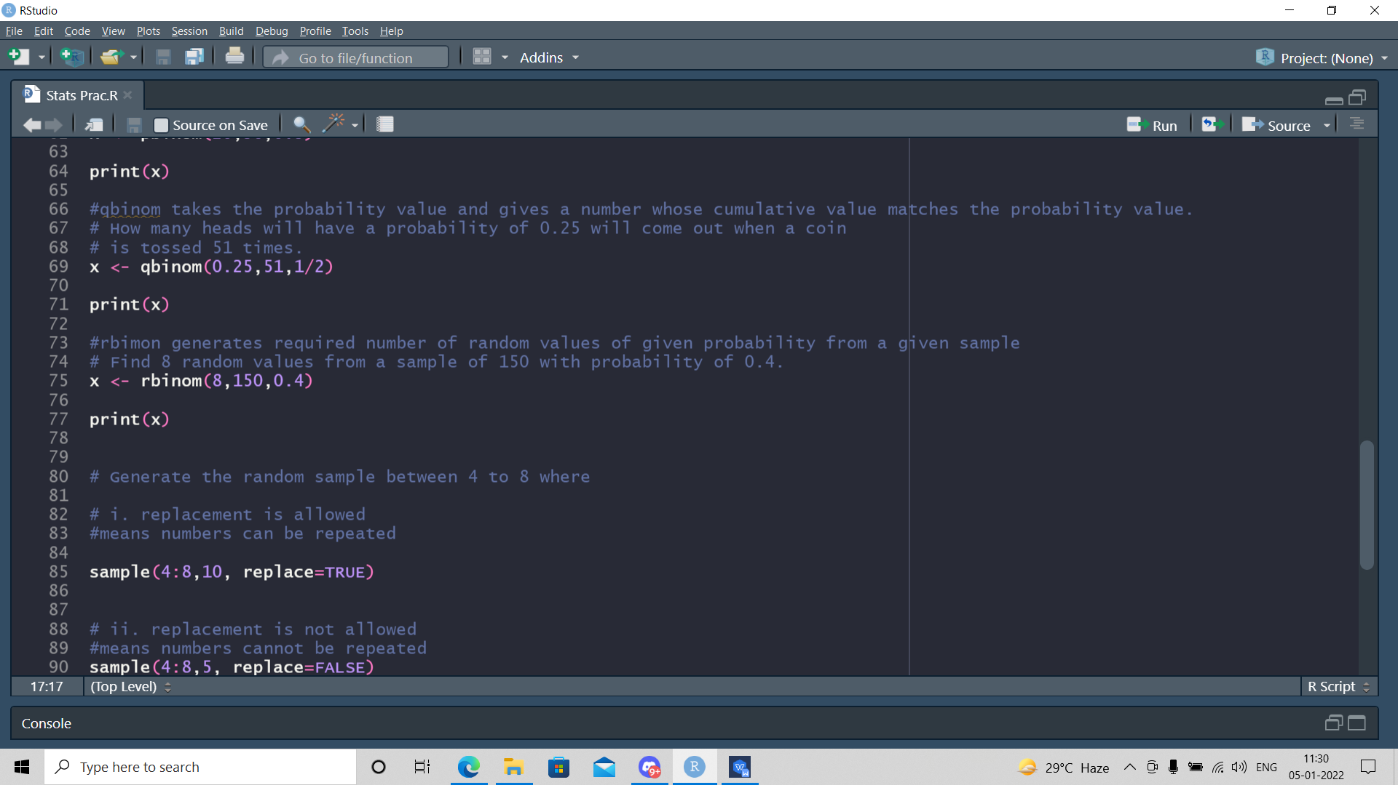

***Output:***

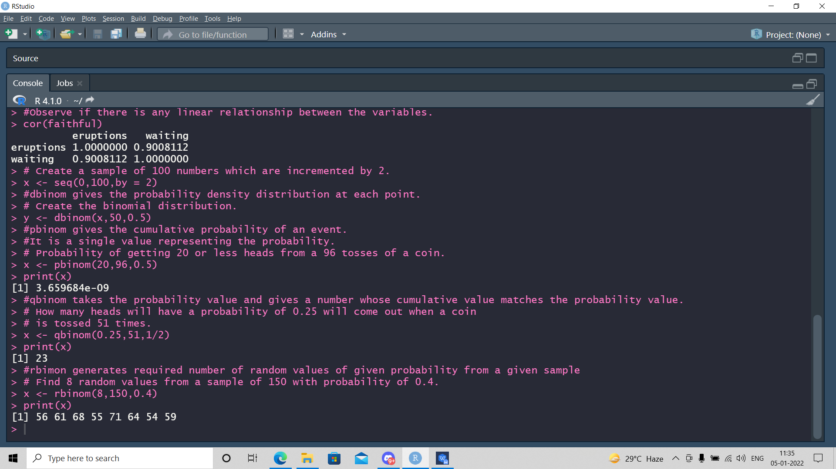

**4. Generate the random sample between 4 to 8 where**

**i. replacement is allowed**

**ii. replacement is not allowed**

# i. replacement is allowed

#means numbers can be repeated

# ii. replacement is not allowed

#means numbers cannot be repeated

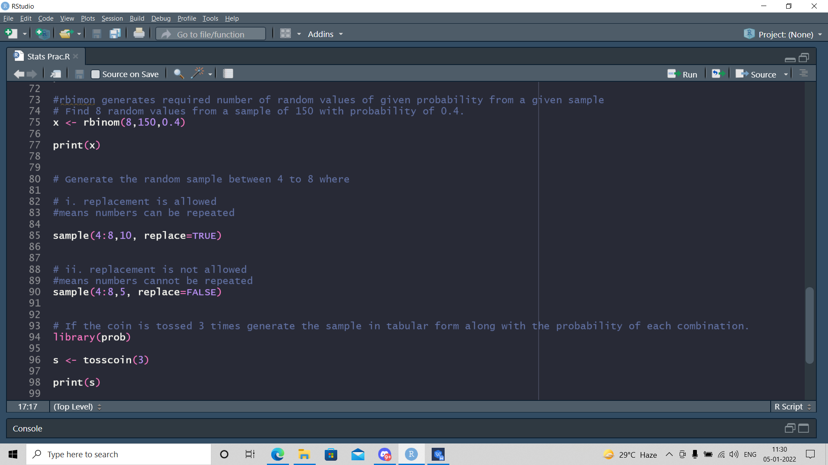

***Output:***

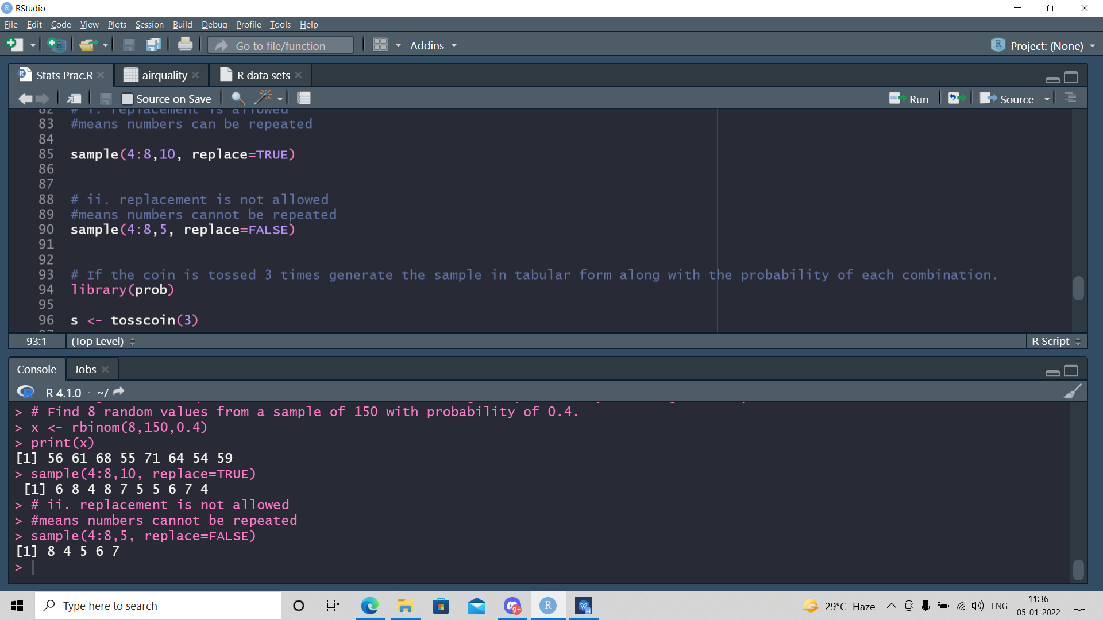

**5. If the coin is tossed 3 times generate the sample in tabular form along with the probability of**

**each combination. Plot the Histogram and scatterplot using R internal data set.**

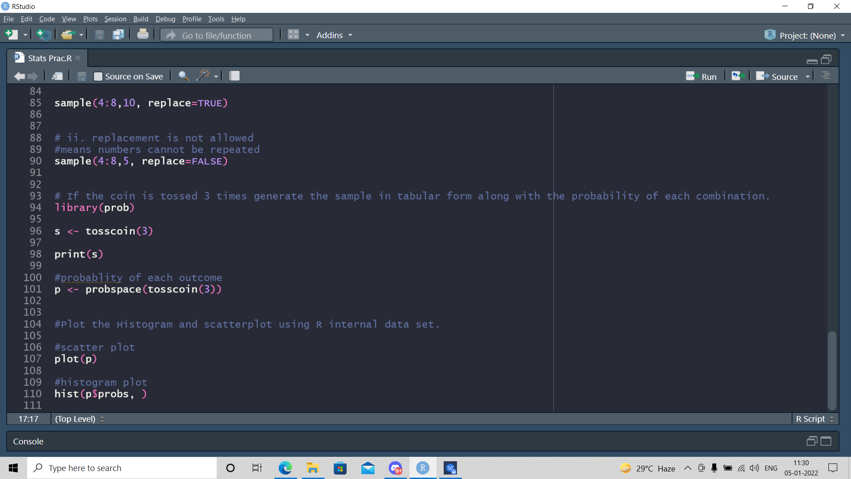

***Output:***